Experiment 9: PWA Testing using Google Lighthouse
Aim
To analyze and test a Progressive Web Application (PWA) using Google Lighthouse and evaluate its performance, accessibility, best practices, SEO, and PWA compliance.
Software Required
- Google Chrome
- Chrome DevTools (Lighthouse)
- VS Code / Android Studio
- Local Server (Live Server / Python)
- HTML, CSS, JavaScript
Theory
Google Lighthouse is an automated tool used to test and improve the quality of web applications. It is built into Google Chrome and provides a detailed report based on five important categories.
Categories Evaluated
- Performance
- Accessibility
- Best Practices
- SEO
- PWA (Progressive Web App)
It also checks:
- HTTPS security
- Manifest file
- Service worker
- Offline support
- Installability
Q1. What is Google Lighthouse?
Google Lighthouse is an open-source tool used to analyze web applications and generate reports on performance, quality, and user experience.
Q2. Five Categories Evaluated
1. Performance
Measures loading speed and responsiveness.
2. Accessibility
Checks usability for all users (including disabled users).
3. Best Practices
Ensures secure and modern coding standards.
4. SEO
Checks if the website is optimized for search engines.
5. PWA
Verifies if the app meets Progressive Web App requirements.

Q3. Purpose of Lighthouse in PWA Testing
- To check if PWA is correctly implemented
- To identify performance issues
- To improve user experience
- To ensure offline functionality works

Q4. Key PWA Requirements Checked
- ✔ HTTPS enabled
- ✔ Manifest file present
- ✔ Service Worker registered
- ✔ Offline functionality
- ✔ Installable

Q5. Performance Metrics
FCP (First Contentful Paint)
Time taken to display first content on screen.
LCP (Largest Contentful Paint)
Time taken to load main content.
CLS (Cumulative Layout Shift)
Measures visual stability (no shifting elements).

Q6. How Lighthouse Helps Improve Performance
- Identifies slow-loading resources
- Suggests optimization (images, scripts)
- Detects unused CSS/JS
- Improves accessibility and SEO

Q7. Practical: Analyze PWA using Lighthouse
Steps
Step 1: Run Project
Live Server OR python -m http.server

Step 2: Open in Browser
- Open your PWA in Google Chrome

Step 3: Open Lighthouse

Right click → Inspect
- Go to Lighthouse tab
- Select all categories
- Click Generate Report

Step 4: Analyze Report
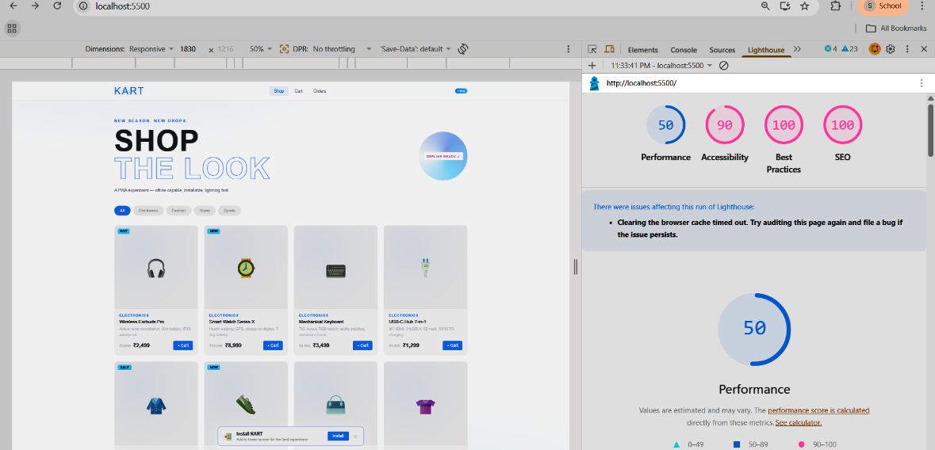
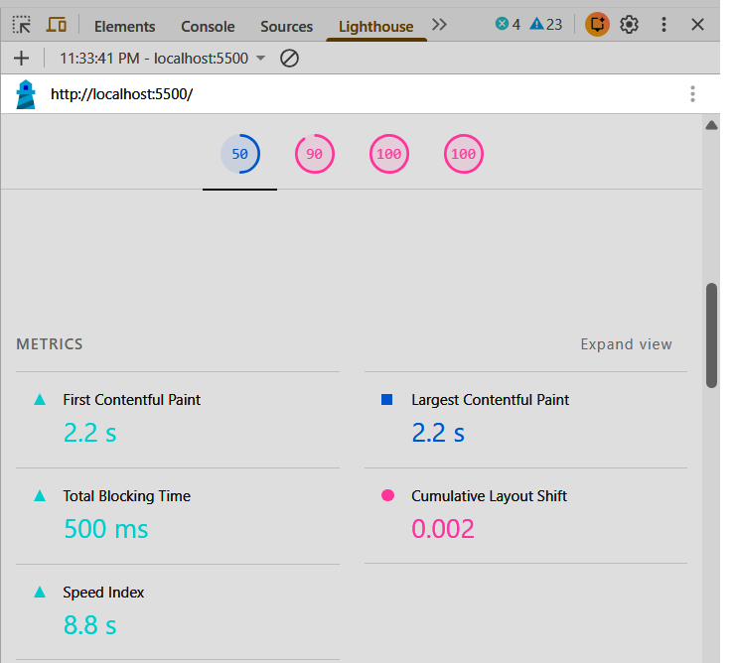
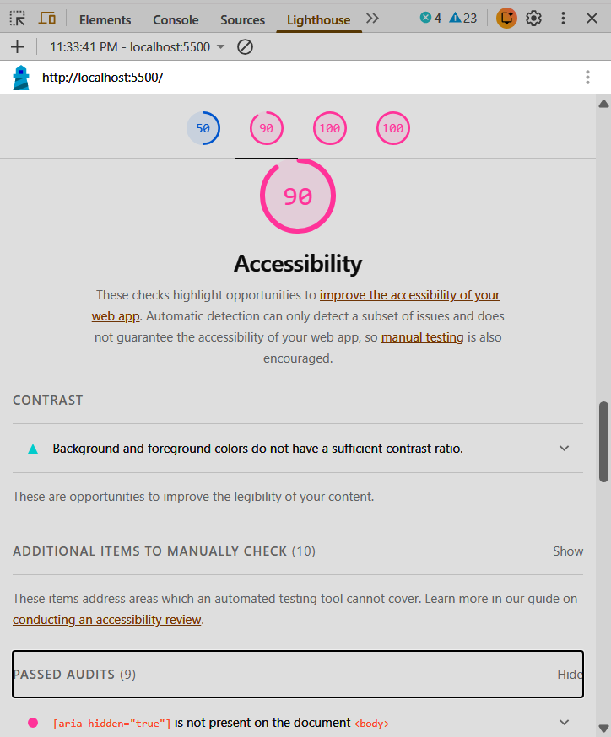
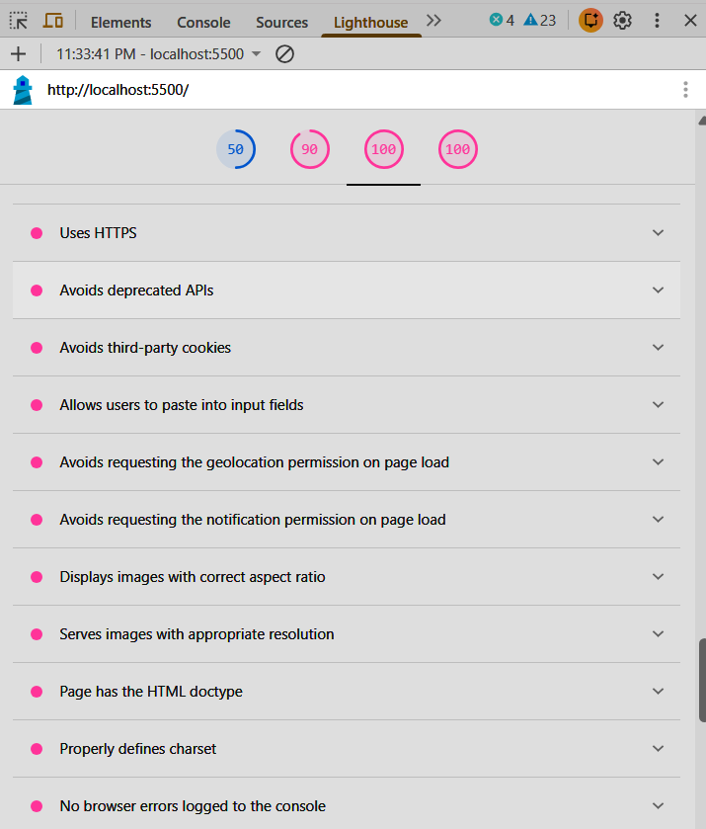
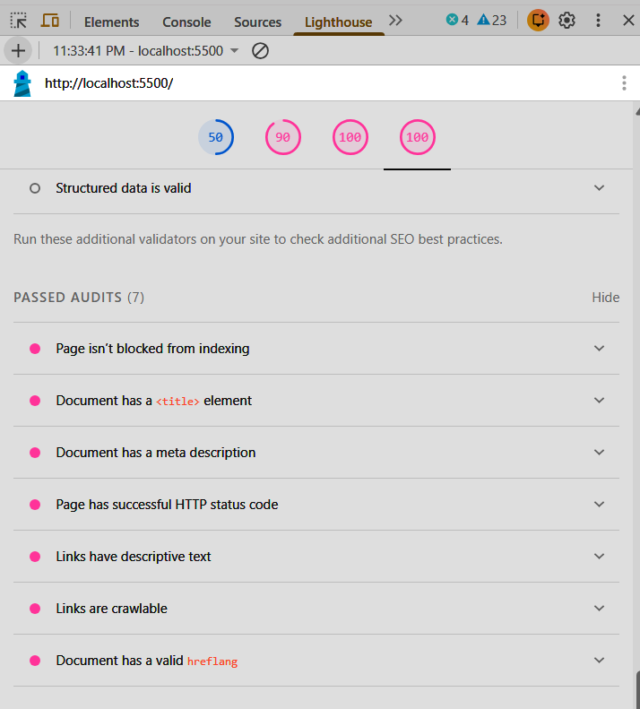

Analysis
- The PWA performs efficiently with fast loading time
- Service worker enables offline functionality
- Manifest file ensures installability
- Minor improvements can be done in performance optimization
Result
The Progressive Web Application was successfully analyzed using Google Lighthouse.
The application meets major PWA requirements and performs well across all categories.

